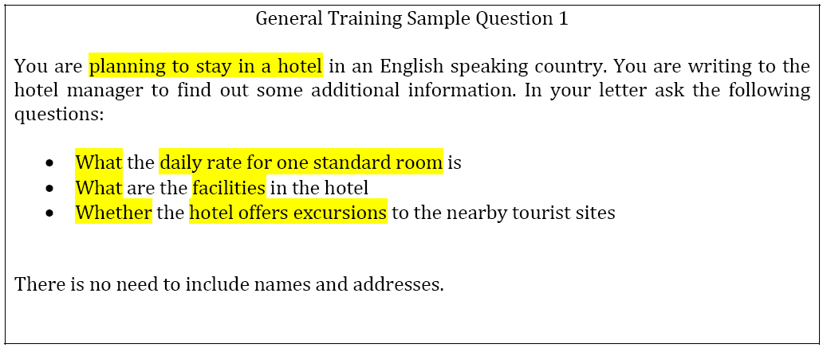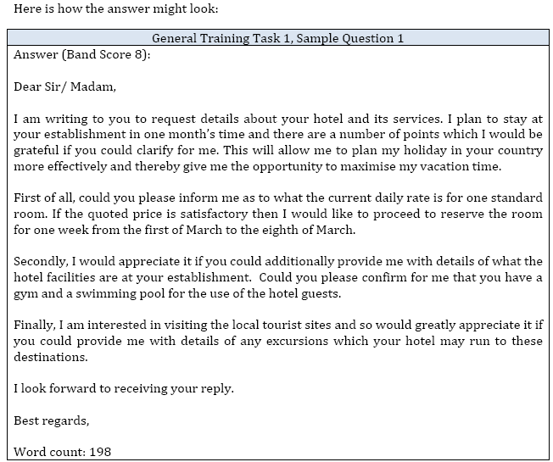
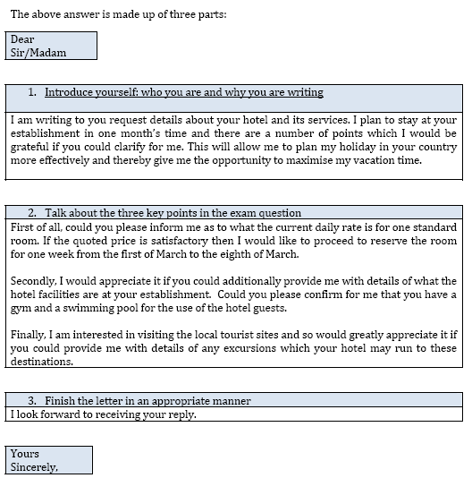
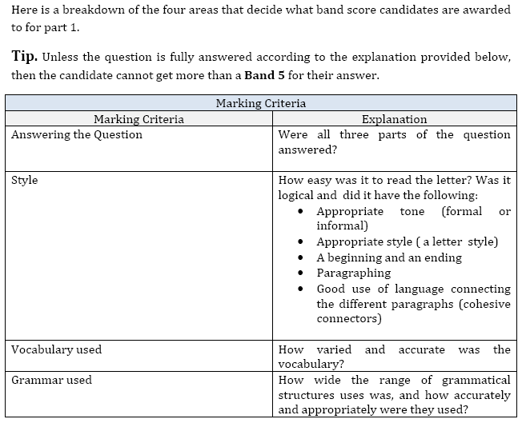
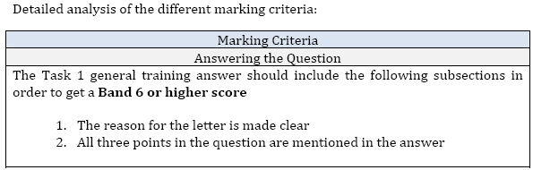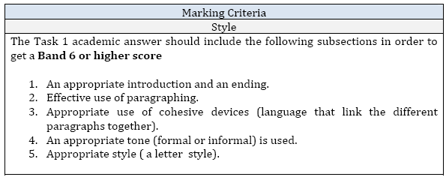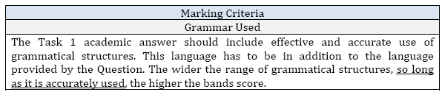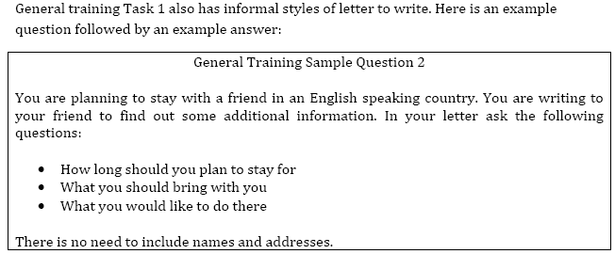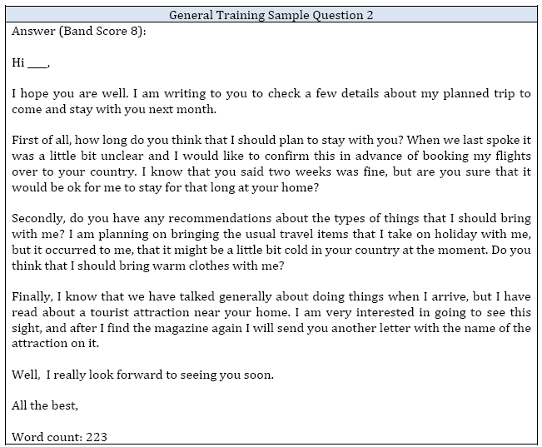
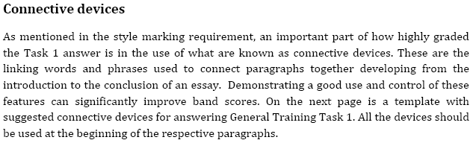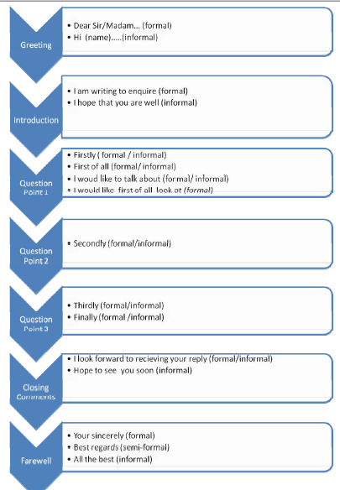

Solved Sample Letters : General Training Task 1
YOU should spend about 20 minutes on this task.
You play a team sport with some friends. Last week a member of the
team had an accident and wasn't able to play with you at the weekend.
You decide to write to him in hospital, telling him about the match.
Write a letter to your friend. In your letter
- tell him which team won
- describe the conditions on the day
- say how you felt about the match
You should write at least 150 words.
General Training Writing Task 1 - Sample Band 9 answer
Dear Frank,
I was so sorry to hear about your accident. I hope you are feelinq a lot better today and that it is not too boring In the hospital.
(Express sympathy and ask about the reader’s health)
The match on Saturday was disappointing. The score was 2 all, probably because you weren't there to score that extra goal. The awful thing was that we were winning until 1O minutes before the end, when suddenly they scored another goal. I was so shocked when I saw the ball hit the back of the net.
(Tell him the score and briefly describe how you felt about the match )
I think the weather was to blame- it was a really wet day and the pitch was very muddy. By the end of the day you could hardly see the grass and we were sliding around in the mud. Everyone was exhausted.
(Mention the weather and conditions)
Let us know when you're going home and we'll arrange for someone to bring you to watch the next game. The rest of the team sends their regards and we all wish you a speedy recovery.
(Finish with good wishes)
Best wishes,
Charlie (161 words)
This is a good answer because it covers all the points in the question, though not necessarily in the same order, and introduces some original ideas. It is well paragraphed and both the introduction and the closing paragraph are appropriate to the situation. The use of adjectives to describe how the writer felt is excellent and there is a good range of structures used. The tone and overall communicative quality of the letter are good.
Sample 2
You should spend about 20 minutes on this task.
You live in a room in college which you share with another student. However, there are many problems with this arrangement and you find it very difficult to work.
Write a letter to the accommodation officer at the college. In the letter,
- • describe the situation
- • explain your problems and why it is difficult to work
- • say what kind of accommodation you would prefer

Write at least 150 words.
You do NOT need to write any addresses.
Begin your letter as follows:
Dear Sir or Madam,
Band 8 Answer-
Dear Sir or Madam
Request to change room
I am writing to ask if I could please be given another room in college.
At present I share a room with another student who, unfortunately, is very noisy. This makes it very difficult for me to study. I have asked this student on many occasions to let me work quietly but there has been no change. He plays his radio or watches TV constantly and often invites friends round for parties which last till late in the night.
I have tried working in the library but it is not open at all the times I need. I am very worried about this situation, as I have to finish my final year project this term and have my final exams coming up at the end of the year.
I would be most grateful if you could please give me a room by myself or a room sharing with a student who is quiet.
I look forward to hearing from you and thank you in advance for your help.
Yours faithfully
Jan Hutt

Solved Letters for practice-
1. LETTER - AS A STUDENT, GIVE REASONS TO YOUR TEACHER FOR OPTING OUT OF HIS COURSE
Dear Professor Moss,
I am Sandy Lee, an undergraduate student of the department of Electrical and Computer Engineering. At the beginning of this semester, I registered for one of your courses, African Literature and Culture. It is a two-hour course held on every Thursday afternoon. Yesterday, I received a notice from my department that a major course, Computer Principle, would be changed to Thursday afternoon. This major course conspicuously influences my credits and it is very important to me. As a result unfortunately, I cannot study your course this semester.
Because of your reputation and my enthusiasm in literature, I hope I could study this course in the next semester. I also heard that another course of yours, China Literature, is held every Friday afternoon. If the registration of this course hasn't closed yet, I will be glad to participate in your class.
Sorry to bother you, your help will be greatly appreciated.
Sincerely yours,
Cindy Lester
2. LETTER - AS A RESTAURANT WORKER, MAKE SUGGESTIONS TO THE RESTAURANT
Dear General Manager,
As a staff member of the Sales Department, I'm very glad to see the rapid development of our hotel. With the coming of New Year, I am writing to you with a suggestion that I think can aid the further improvement of our hotel.
I suggest that we should establish a website of our own to attract more clients.
Firstly, with the development of Internet, more and more people are willing to go to the outside world through the information on Internet. Thus if we could establish our own website and introduce ourselves on it, more friends, especially foreign friends, could know our latest promotion at home whenever they want.
Secondly, according to the statistics of World Hotel Association, 33% of clients made hotel reservation through the Internet last year. And the proportion will largely increase in the coming years. Thus if we could introduce reservation system on our homepage, clients could contact us and make reservation directly.
Finally, hotel promotion on Internet could reduce our operation cost greatly.
As someone says that the Internet shortens the distance of the world, I believe that the one who could make use of Internet effectively today will be the winner tomorrow. We will gain a lot and have a brilliant future.
Yours faithfully,
Tom Jones

3. LOST SOMETHING ON AN AIRPLANE AND WIRTE TO THE AIRPORT FOR HELP
Dear Sir
Personal items lost on flight
On 01/01/2015, I took flight CA983 from London to Los Angeles. When the flight arrived at Los Angeles, because of my carelessness, I left my handbag, a black leathered bag, on my seat. There are some important things in it, including my passport, ID card, credit card, some checks and one thousand US dollars. But the most important thing is my business address book, in which record all my clients' phone numbers and appointment agenda in the following two weeks.
Since this bag is very important to me, my friends told me that I should contact your department to seek help, so I write this letter to you anxiously. Hope you and your staff can help me find my lost bag. Your meticulous and warmhearted help will be greatly appreciated.
For information about my lost items, please contact me in the following ways.
Mobile phone: 13901160xxx
Home phone: 8232xxxx
Office phone: 8232xxxx
Yours faithfully
Warren Stone
4. SOMEBODY HAS DONATED CONSIDERABLE MONEY; WRITE TO SCHOOL ABOUT HOW TO USE IT
Dear Sir
I 'm very happy to hear that a famous author has donated considerable money to our institute. I think we could use it to establish an education fund to aid our teachers to study abroad.
Firstly, teachers could increase their teaching level and enrich their knowledge by studying aboard. For teachers of a language institute, this kind of experience is really necessary. Teachers would consider that as a kind of prize and therefore work harder for that. Secondly, our institute could be benefited from doing that. Since we could provide the overseas-studying chance for our teachers, graduates with high score in the colleges are more willing to come to our institute. Thirdly, that will help our students. Our last year's survey showed that 65% of our students prefer the language teachers who had overseas-studying experience.
In a word, I think that using the donated fund to assist our teachers to study abroad is a good way to promote the healthy development of our institute.
Please take good consideration of my advice. Thanks!
Yours faithfully,
Lydia Woods
5. PRAISE A RESTAURANT FOR THE QUALITY OF THEIR FOOD AND THE IMPROVED MENU
Dear Manager,
I am a reporter from the News Weekend. Because of the demand of my work, I often come to Bangkok to do interviews. Your hotel is my favorite, because of the comfortable living conditions, and the considerate service, especially your excellent food.
The restaurants in your hotel have many kinds of delicious food such as Chinese food, Japanese food, French food and so on. Among these delicious foods, I like the Beijing Toast Duck best, not only because of its Chinese characteristics but also its special taste for people from all over the world. So every time I come here I always choose this course.
Furthermore, what impressed me most is the high quality service, it always makes me feel at home. Waiters and waitresses are so kind and warmhearted that they always earnestly recommend every new or special food of the restaurant. I will recommend your hotel and restaurant to my friends without any reservation and hesitation.
Hope your hotel and restaurant will be more prosperous in the future.
Sincerely yours,
Sam Hunter
6. Letter of request
Dear Sirs,
We are planning a full day party to celebrate the completion of our Business Language Training Course on June 30, 2000. The party will start at 10:00. The president of our institute will deliver an opening speech. After lunch comes the singing and dancing show, followed by a cake and champion celebration at 17:00. Karaoke and disco will begin at 18:30 and end at about 12:30. There will be 100 to 150 attendees for the event and half of them will stay overnight at the hotel.
As suggested by one of our professors, your hotel offers various recreational facilities. Therefore, we would like to make your hotel as our party's venue. Please reserve the following according to our program:
A 150-square meter meeting room, theater-style with 2 standing
microphones, 5 wireless microphones and 1 podium;
A 18-meter banner;
Buffet lunch including soft drink;
60-centimeter cakes and 30 bottles of champagne;
60 standard rooms
Please quote the above separately and let us know the term of payment. Should
you have further questions, please feel free to contact me.
Contact Way: Tel: 6888xxx/68882xxx
Fax: 6888xxx
Thank you in anticipation for your kind assistance and looking forward to your
earliest reply.
Yours faithfully,
Kathy Bryce
Celebration Party Preparation Committee
7. WRITE TO PRAISE HOSPITAL'S SERVICES
Dear Sir,
I am a business man from America, and my name is David Smith. Last month it was the first time that I traveled to London for business, signing a contract with a British food company. Unfortunately I got a bad flu and then had a fever. I was sent to your hospital. Because my temperature was nearly 40 degree centigrade, I was asked to be in hospital. I worried about my business and the delay of signing the contact will lead to great losses to my company. However, After the doctors' careful treatment and nurses' patient care, I was recovered only in 4 days.
I completed the negotiation with the food company smoothly and signed the contract on time finally. So I sincerely appreciate all the staffs in your hospital who helped me full-heatedly. I was deeply impressed by the kind doctors and nurses, the pleasant and comfortable environment, and considerate services. I have no relatives and friends in Beijing, but I felt at home in your hospital. I will always remember all those warmhearted persons and your hospital in my heart.
Best wishes to you all!
Yours faithfully,
Harold Davidson

